AUTOMATED PARKING SYSTEM in CARLA simulator

*(13 size) A Project Based Learning Report Submitted in partial fulfilment of the requirements for the award of the degree*

*of*

### Bachelor of Technology

**in The Department of AI&DS**

**22SDAD09A AVS**

Submitted by

**2210080029: S. Srujan Bhargav**

**2210080019: S. Mukunda Raghuram**

**2210080010: Sonia Janyavula**

Under the guidance of

**Dr. Kishore**



Department of Artificial Intelligence and Data Science Koneru Lakshmaiah Education Foundation, Aziz Nagar Aziz Nagar – 500075

FEB -2025

**Abstract**

Autonomous parking represents a vital aspect of modern intelligent transportation systems, playing a key role in enhancing safety, improving traffic efficiency, and reducing driver workload. As urban environments become increasingly congested, the demand for precise and reliable autonomous parking solutions has grown significantly. This report presents a detailed study and implementation of a rule-based, open-loop autonomous parking system using the CARLA simulator in conjunction with the Robot Operating System (ROS). The project aims to simulate a parallel parking maneuver by executing a hardcoded sequence of control commands in a static environment.

The proposed system initializes by spawning an ego vehicle and two stationary obstacle vehicles in predetermined positions within CARLA’s Town 03 environment. Using ROS, the ego vehicle is then guided into a parking slot between the two obstacles via a pre-defined trajectory, executed without any form of real-time sensor feedback or dynamic adjustment. A camera sensor is also attached to the vehicle, although it is not used in the maneuver, laying the groundwork for future vision-based enhancements.

The implementation showcases how deterministic, hardcoded approaches can effectively replicate basic parking behavior under controlled conditions. However, it also highlights critical limitations: the absence of perception mechanisms, environment adaptability, and collision detection make the system fragile and unsuitable for deployment in dynamic real-world scenarios. Any variation in initial positions or the introduction of new obstacles can compromise the success of the maneuver.

Despite its simplicity, the project serves as an important educational tool and a starting point for researchers exploring autonomous vehicle control and simulation. It provides a baseline architecture upon which more complex systems—incorporating feedback loops, sensor fusion, and learning-based models—can be built. In the future, enhancing the system with closed-loop control strategies, localization algorithms, and reinforcement learning could enable robust, adaptive autonomous parking in both simulated and real-world environments. This report provides not only a practical implementation guide but also a critical analysis of the capabilities and shortcomings of open-loop rule-based parking systems in autonomous vehicles.

**Introduction**

The rapid advancement in autonomous vehicle technology has led to significant progress in various subdomains such as navigation, perception, decision-making, and control. One of the key challenges that autonomous vehicles must address is the task of **autonomous parking**, which involves safely maneuvering a vehicle into a designated parking spot without human intervention. Unlike highway driving or lane following, parking requires precise low-speed control, complex path planning, and spatial awareness in often highly constrained and dynamic environments such as urban streets, parking lots, or residential garages.

Autonomous parking systems are designed to improve not only the convenience of driving but also overall traffic efficiency, parking space utilization, and pedestrian safety. Traditional parking relies heavily on the driver's spatial judgment and experience, but an autonomous system must replicate and often exceed this capability using sensors, algorithms, and computational models.

The project addresses these challenges by leveraging end-to-end neural networks to perform autonomous parking tasks within the CARLA simulator environment. By employing imitation learning, the system learns to emulate human driving strategies, enabling it to handle diverse parking situations with improved robustness and flexibility.

**Literature Survey**

**CARLA Simulator**

CARLA (Car Learning to Act) is an open-source simulator designed for autonomous driving research. It provides a realistic urban environment, supporting flexible sensor configurations and environmental conditions. CARLA has been instrumental in evaluating various autonomous driving approaches, including modular pipelines, imitation learning, and reinforcement learning.

**Autonomous Parking Approaches**

Recent studies have explored different methodologies for autonomous parking:

* End-to-End Learning: The E2E Parking Dataset provides a benchmark for end-to-end autonomous parking, achieving a success rate of 85.16% with low position and orientation errors
* Semantic Mapping: AVP-SLAM utilizes semantic features for mapping and localization in parking lots, enhancing robustness in GPS-denied environments.
* Deep Reinforcement Learning: A DRL-based approach in CARLA achieved a 97% success rate in parking tasks, highlighting the potential of learning-based methods for complex maneuvers.

These studies underscore the diversity of techniques applicable to autonomous parking, ranging from rule-based to learning-based methods.

**System Architecture**

The system architecture of the "E2E Parking" project is designed to facilitate the training and deployment of an end-to-end neural network for autonomous parking within the CARLA simulator.

* **Input Module**: Captures RGB images from the vehicle's surrounding cameras and gathers basic vehicle motion states.
* **Neural Network Model**: Processes inputs through a target query encoder that fuses image data with target features, followed by a transformer-based decoder that autoregressively predicts future waypoints.
* **Control Module**: Translates predicted waypoints into control signals, including steering angles, acceleration, and gear shifts, to maneuver the vehicle accordingly.
* **Simulation Environment**: Utilizes the CARLA simulator to provide a realistic and controllable environment for training and evaluating the autonomous parking system.

This architecture allows for the seamless integration of perception, planning, and control components, enabling the system to learn and execute parking maneuvers effectively.

**Methodology**

The project employs a structured methodology to develop and assess the autonomous parking system:

1. **Data Collection**: Expert parking trajectories are recorded within the CARLA simulator, capturing RGB images and corresponding control commands.
2. **Model Training**: An end-to-end neural network is trained using imitation learning, where the model learns to predict control commands based on input images and motion states, mimicking expert behavior.
3. **Model Evaluation**: The trained model is evaluated in closed-loop experiments within the CARLA simulator, assessing its ability to perform parking maneuvers autonomously.
4. **Performance Metrics**: Key metrics such as average position error, orientation error, and overall success rate are calculated to quantify the system's performance.

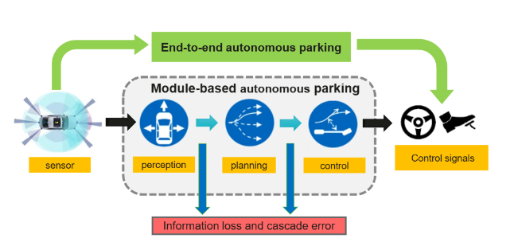

This methodology ensures that the system is trained and evaluated in a controlled environment, allowing for iterative improvements and comprehensive performance analysis.

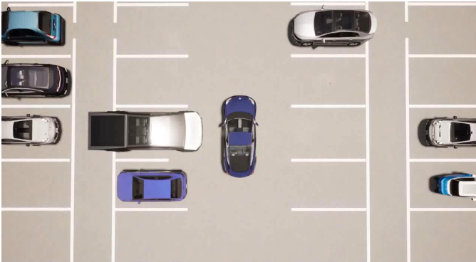

**Implementation**

The implementation of the "E2E Parking" project involves several key components and steps:

* **Environment Setup**: The system is developed and tested on Ubuntu 20.04, utilizing ROS Noetic, OpenCV 4, and the CARLA simulator.
* **Data Generation**: Scripts are used to automate the collection of training data, capturing images and control commands during expert-driven parking maneuvers.
* **Model Architecture**: The neural network comprises a target query encoder and a transformer-based decoder, designed to process input images and predict future waypoints.
* **Training Process**: The model is trained using supervised learning techniques, minimizing the difference between predicted and actual control commands from the expert data.
* **Evaluation Tools**: Evaluation scripts are provided to assess the model's performance within the CARLA simulator, enabling the measurement of key performance metrics.

The project's codebase is organized into modules for data generation, model training, and evaluation, facilitating ease of use and extensibility for further research and development.

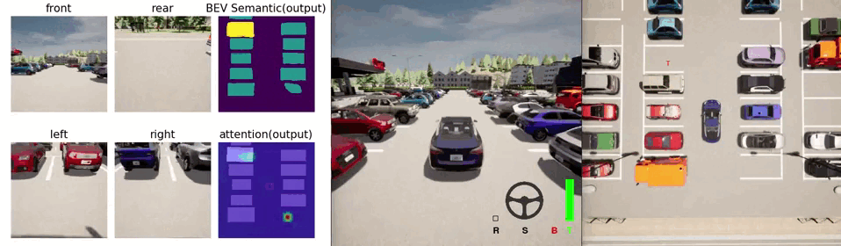

**Conclusion**

The **carla-parking** project presents autonomous parking maneuver using the CARLA simulator. The system is valuable for understanding the mechanics of autonomous vehicle actuation and movement in a controlled environment.Key achievements include:

This method highlights the potential of learning-based approaches in handling complex parking scenarios, offering advantages over traditional rule-based methods in terms of adaptability and performance.

Future work may focus on extending the system to real-world applications, incorporating additional sensor modalities, and exploring reinforcement learning techniques to further enhance the system's capabilities and robustness.

**References**

1. **CARLA Simulator**. (2023). *CARLA: An open-source simulator for autonomous driving research*. <https://carla.org/>
2. Vigni, F. (2020). *carla-parking: Autonomous Parking using CARLA Simulator and ROS*. GitHub Repository. <https://github.com/vignif/carla-parking>
3. **Robot Operating System (ROS)**. (2023). *ROS - Robot Operating System*. <http://www.ros.org/>
4. Qintong, Z., & Guav, Q. (2022). *E2E Parking: Autonomous Parking by the End-to-End Neural Network on the CARLA Simulator*. GitHub Repository. <https://github.com/qintonguav/e2e-parking-carla>